**Week 5 : In-Class Exercises (Lists)**

**Q1: Code Tracing [ ** ]**

What’s the output of the following code?

def modify_list(my_list):

    for index in range(len(my_list)):

        x = my_list[index]

        if len(x) > 5:

            my_list[index] = x[0:5]

str_list = ["IS111", "Python", "Programming", "List"]

modify_list(str_list)

print(str_list)

What’s the output of the following code?

def modify_list(my_list):

    for element in my_list:

        if len(element) > 5:

            element = element[0:5]

str_list = ["IS111", "Python", "Programming", "List"]

modify_list(str_list)

print(str_list)

**Q2: Email Extractor [ ** ]**

**Part I**

Implement a function called extract_email_id() that extracts email ID from an email address. The function takes in a string as a parameter. This string is supposed to be an email address. The function **returns** the front part of the email address before the ‘@’ symbol.

For example,

* extract_email_id("jerry.lee@sis.smu.edu.sg") returns the string "jerry.lee".
* extract_email_id("alan_wong@gmail.com") returns the string "alan_wong".
* extract_email_id("alan_wong.com") returns "".
* extract_email_id("") returns "".

If the given string does not contain the ‘@’ symbol, the function returns an empty string. You can assume that the string either contains a single ‘@’ symbol or no ‘@’ symbol.

Use the test code provided below to test your code.

print(extract_email_id("jerry.lee@sis.smu.edu.sg"))

print(extract_email_id("alan_wong.com"))

print(extract_email_id(""))

print(extract_email_id("alan_wong@gmail.com"))

It should provide the following output:

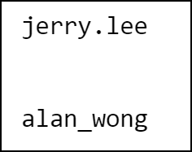

**Part II**

Implement another function called extract_multiple_email_ids(). This function takes in a string that contains multiple email addresses, separated by semi-colons. (You can assume that semi-colons cannot be used as part of an email address.) The function **prints out** the email IDs one by one in separate rows. The function doesn’t return anything.

For example, calling extract_multiple_email_ids("jerry.lee@sis.smu.edu.sg;alan_wong@gmail.com;george_tan@yahoo.com") gives the following output:

jerry.lee  
 alan_wong  
 george_tan

Use the test code below to test your code:

extract_multiple_email_ids("jerry.lee@sis.smu.edu.sg;alan_wong@gmail.com;george_tan@yahoo.com")

extract_multiple_email_ids("")

extract_multiple_email_ids("jerry.lee@sis.smu.edu.sg")

It should provide the following output:

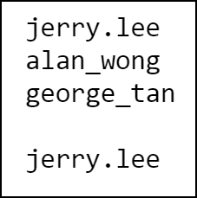

Hint: You can use the split() method on a string.

**Q3: Check Username [ *** ]**

A website allows people to sign up as members, but when choosing their usernames, there are the following restrictions:

* The username cannot be empty nor contain any space.
* Each character in the username must be a lowercase letter, a digit, or one of the following special symbols: _.!#$%?
* The length of the username cannot exceed 8.

Write a function that checks whether a string is a valid username. The function takes in a string as its parameter and **returns** True or False.

Use the test code provided below to test your function.

username_list = ['ab{cdefgh','abcdefghi','ab$cd','ab_cd','ab-cd','ab:cd','','ab cd','abcDef','abc8ef']

for username in username_list:

    print("The username '" + username +"' is valid : " + str(is_valid_username(username)))

It should provide the following output:

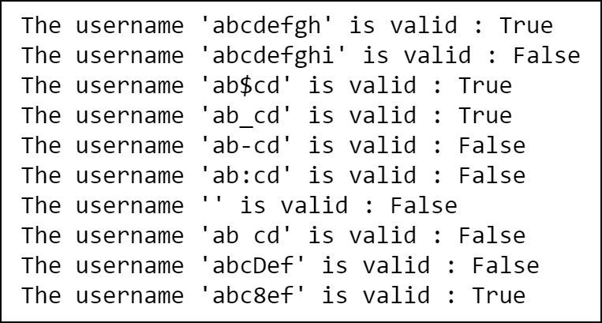

**Q4: List of Strings**

1. [ ** ] Implement a function called get_avg_len() that takes in a list of strings. The function returns the **average length** of all the strings in the given list.

For example, get_avg_len(["C", "Java", "Python", "PHP"]) returns 3.5.

If the list is empty or if the strings are all empty strings, the function returns 0.

Use the test code provided to test your function.

print(get_avg_len(["C", "Java", "Python", "PHP"]))

print(get_avg_len([]))

It should provide the following output:

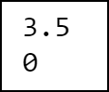

1. [ ** ] Implement a function called get_longest_str() that takes in a list of strings. The function returns the string that is the **longest** among all the strings in the given list. If there are multiple strings having the longest length, the function returns the **first** such string in the list.

For example, get_longest_str(["C", "Java", "Python", "PHP"]) returns "Python", and get_longest_str(["C", "Java", "HTML", "PHP"]) returns "Java".

If the list is empty, the function returns an empty string.

Use the test code provided to test your function.

print(get_longest_str(["C", "Java", "Python", "PHP"]))

print(get_longest_str([]))

print(get_longest_str(["C", "Java", "HTML", "PHP"]))

It should provide the following output:

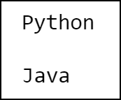

1. [ *** ] Implement a function called concatenate_emails(). This function takes in a list of strings, where some of these strings are email address. The function **returns** a string that contains the email addresses separated by semi-colons.

Here a string is considered an email address if it contains exactly one ‘@’ symbol and it does not contain any space.

For example, concatenate_emails(["IS111", "a @ b", "jerry.lee@sis.smu.edu.sg", "@@@", "alan_wong@gmail.com", "Python", "george_tan@yahoo.com"]) returns "jerry.lee@sis.smu.edu.sg;alan_wong@gmail.com;george_tan@yahoo.com".

If the list is empty, the function returns an empty string.

Use the test code provided to test your function.

my_list1 = ["tommy.goh@sis.smu.edu.sg","alan_wong@gmail.com"]

print(concatenate_emails(my_list1))

my_list2 = []

print(concatenate_emails(my_list2))

my_list3 = ["IS111", "a @ b", "jerry.lee@sis.smu.edu.sg", "@@@", "alan_wong@gmail.com", "Python", "george_tan@yahoo.com"]

print(concatenate_emails(my_list3))

It should provide the following output:

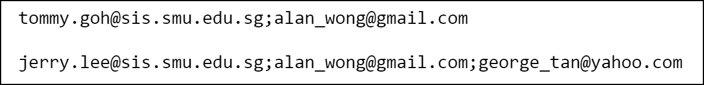

1. [ *** ] Implement a function called check_hashtags(). The function takes in a list of strings. The function returns True if all the strings are hashtags, i.e., all the strings start with a ‘#’ symbol and do not contain any space. The function **returns** False if at least one of the strings is not a hashtag.

For example,

* check_hashtags(["#singapore", "#music", "#travel"]) returns True
* check_hashtags(["#singapore", "#music album", "#travel"]) returns False
* check_hashtags(["singapore", "#music", "#travel"]) returns False

If the list is empty, the function returns False.

Use the test code provided to test your function.

print(check_hashtags(["","#singapore", "#music", "#travel"]))

print(check_hashtags([]))

print(check_hashtags(["#singapore", "#music album", "#travel"]))

print(check_hashtags(["singapore", "#music", "#travel"]))

It should provide the following output:

